


Endoscopic Medial Maxillectomy for Sinonasal Inverted
Papilloma: Evolution Toward Anatomy-Preserving
Techniques
Kholoud M. Hassan¹, Alaa M. Abdelsamie¹, Hossam M. Abdelazeem¹
¹ Otorhinolaryngology Department, Faculty of Medicine, Benha University
E-mail: 5o5a.mohammed2016@gmail.com

Abstract

Background: A benign tumor that originates from the Schneiderian mucosa of the nasal cavity and paranasal sinuses is known as a sinonasal inverted papilloma (IP). It demonstrates locally aggressive growth, a tendency for postoperative recurrence, and a recognized potential for malignant transformation in approximately 5–15% of cases. Complete surgical excision with precise identification and removal of the point of tumor attachment is essential for management, especially for lesions in the maxillary sinus. In the past, external approaches were commonly used to ensure sufficient exposure but were linked to significant morbidity.
Objective: To summarize the evolution of endoscopic medial maxillectomy (EMM) for sinonasal IP, focusing on anatomy-preserving strategies and their clinical outcomes.
Methods: This narrative review summarizes the evolution of EMM for sinonasal IP, with emphasis on anatomy-preserving modifications designed to maintain nasal physiology while ensuring adequate tumor resection.
Results: The invention of endoscopic sinus surgery represented a significant advancement in the management of sinonasal IP. Endoscopic medial maxillectomy (EMM) offers a comprehensive approach to the maxillary sinus, enabling total tumor excision while avoiding external incisions. Despite its efficacy, traditional EMM frequently requires resection of the inferior turbinate and nasolacrimal duct, which may result in postoperative morbidities such as epiphora and symptoms of empty nose syndrome. Anatomy-preserving modifications of EMM have been developed, including inferior turbinate sparing, nasolacrimal duct preservation, prelacrimal recess preservation, and extended anterior/inferior approaches, allowing adequate tumor resection with reduced morbidity.
Conclusion: Anatomy-preserving modifications of EMM allow for effective management of sinonasal IP while preserving nasal physiology and reducing postoperative morbidity.

Keywords: Endoscopic medial maxillectomy; Sinonasal inverted papilloma; Anatomy-preserving surgery; Maxillary sinus; Endoscopic sinus surgery

- Introduction
A benign epithelial tumor that is frequently encountered in the sinonasal tract is known as a sinonasal inverted papilloma (IP). It is recognized for its aggressive growth pattern, high likelihood of recurrence following surgery, and potential to develop into malignant tumors (Krouse, 2000). Because of these characteristics, careful surgical planning and ongoing postoperative monitoring are essential to maintain effective disease control and promptly identify and signs of recurrence or malignant transformation (Lund et al., 2010).
The maxillary sinus poses a unique challenge in the surgical management of IP due to its intricate anatomy and the difficulty in visualizing critical regions such as the anterior wall, alveolar recess, inferior wall, and prelacrimal recess. Tumor attachment in these areas often leads to incomplete excision and higher recurrence rates when surgical exposure is insufficient (Hosemann et al., 2003). In the past, external approaches including lateral rhinotomy, Caldwell–Luc procedures, and open medial maxillectomy were frequently employed to address these limitations and enhance access to the maxillary sinus (Robey & Sindwani, 2011).
The invention of endoscopic sinus surgery marked a significant milestone in the management of sinonasal IP. Endoscopic medial maxillectomy (EMM) enabled improved visualization and exposure to the maxillary sinus while avoiding external incisions and their associated morbidity (Kamel, 1995). Several studies have shown oncologic outcomes comparable to, or even better than, those of traditional open techniques. However, classical EMM usually involves resection of the inferior turbinate and nasolacrimal duct, which could negatively impact nasal airflow dynamics and lacrimal drainage (Wormald et al., 2003).
Concerns regarding the functional morbidity associated with classical EMM have resulted in the evolution of techniques that preserve normal anatomy. Techniques including endoscopic modified medial maxillectomy (EMMM) and the prelacrimal recess procedure aim to maintain oncologic safety while preserving critical anatomical structures and nasal physiology (Nakayama et al., 2012). These approaches have been linked to low recurrence rates, decreased postoperative complications, and improved functional outcomes (Suzuki et al., 2017).
This narrative review outlines the evolution of endoscopic medial maxillectomy in the management of sinonasal inverted papilloma, with a particular emphasis on anatomy-preserving techniques.
- Sinonasal Inverted Papilloma:
2.1. Background and Clinical Considerations
Sinonasal IP comprises about 0.5–4% of tumors of the sinonasal tract and typically affects individuals aged 40–70 years, with a higher incidence in males. Histologically, it is marked by the invagination of stratified squamous epithelium into the underlying stroma, distinguishing it from exophytic papilloma and oncocytic papilloma. Despite its benign nature, IP displays aggressive local behavior, with recurrence rates reported in the literature ranging from 10–20%, and sometimes s even higher. Additionally, there is a well-documented risk of malignant transformation in about 5-15% of cases (Krouse, 2000; Lund et al., 2010).
The etiology of sinonasal inverted papilloma remains multifactorial and not fully understood. Proposed contributing factors include chronic sinonasal inflammation, smoking, occupational and environmental exposures, and viral infections particularly human papillomavirus (HPV) (Lisan et al., 2016; Lund et al., 2010).
The etiological role of human papillomavirus (HPV) in sinonasal inverted papilloma remains controversial. While HPV has historically been linked to the pathogenesis of IP, large studies demonstrate a low prevalence of HPV DNA in these tumors (Fulla et al., 2020). This suggests that HPV is unlikely to be a primary etiological factor. However, HPV positivity has been associated with molecular alterations linked to malignant transformation, indicating a potential role in tumor progression rather than initiation (Lisan et al., 2016).
  - Approaches for Diagnosis of Sinonasal Inverted Papilloma
- Clinical Evaluation
Sinonasal inverted papilloma typically presents with unilateral nasal blockage, discharge, or bleeding. The significance of unilateral symptoms in raising suspicion was emphasized by Lund et al. (2010) and Chhabra & Houser (2009).
- Nasal Endoscopy
Diagnostic nasal endoscopy typically reveals a unilateral, lobulated lesion arising from the lateral nasal wall or middle meatus allowing for a directed biopsy (Fig. 1) (Hosemann, 2003; Krouse, 2000).
- Histopathological Examination
Histopathological examination is still the definitive method for diagnosis, showing the inversion of stratified squamous epithelium into the stroma (Bishop, 2017). A biopsy is necessary to confirm diagnosis and rule out dysplasia or carcinoma (Han et al., 2001).
- Computed Tomography (CT)
CT imaging is crucial for evaluating the extent of disease and bony anatomy, with focal hyperostosis suggesting the site of tumor origin (Fig. 2) (Robey & Sindwani R, 2011).
- Magnetic Resonance Imaging (MRI)
MRI aids in differentiating inverted papilloma from inflammatory tissue, with the characteristic cerebriform pattern being highly suggestive (Fig. 2) (Kim et al., 2012; Ojiri et al., 2000).
- Radiologic–Endoscopic Correlation
Correlation between imaging findings and endoscopic appearance improves diagnostic accuracy and localization of the tumor attachment site (Zhou et al., 2018).

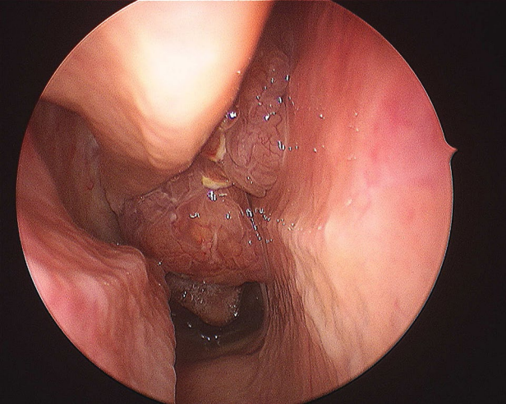
Figure (1): Sinonasal inverted papilloma typically present as a lobulated mucosal mass (Bishop, 2017).
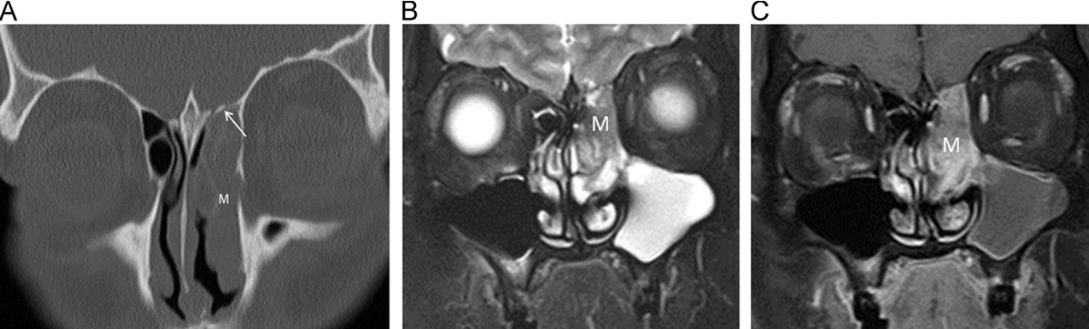
Figure (2): (A) Coronal CT showing left sided opacity (B) Coronal T2W and (C) contrast-enhanced MRI showing mass (M) with typical cerebriform pattern within the ethmoid sinus (Chawla et al., 2016).

The maxillary sinus is among the sites most frequently involved in sinonasal IP, either as a primary site of origin or through secondary extension from the nasal cavity. The tumor commonly involves attachment to regions that are anatomically challenging, including the anterior wall, inferior wall, alveolar recess, and prelacrimal recess. Limited
access to these areas has historically led to residual disease and increased recurrence rates, highlighting the importance of sufficient surgical exposure (Hosemann et al., 2003; Wormald et al., 2003).
Recent advances in management of IP emphasize pedicle-oriented surgery. The primary surgical objective is the recognition and complete excision of the tumor origin. Endoscopic medial maxillectomy and its anatomy-preserving variants are considered pedicle-oriented approaches tailored to expose and eradicate the site of tumor origin (Zhou et al., 2018).
Nakayama et al. (2021) reported that there is no universally recognized staging system for IP, with multiple classifications based on tumor extent currently in use. These include those proposed by Krouse (2000), Oikawa et al. (2007), Han et al. (2001), and Cannady et al. (2007) More recently, Meng et al. (2019) established a staging system determined by the tumor’s site of origin.
Table (1): Staging Systems for Sinonasal Inverted Papilloma (Nakayama et al., 2021).
Krouse (2000)
SNIP restricted to the nasal cavity | T1
SNIP restricted to ethmoid sinuses, and/or medial wall of the maxillary sinus | T2
SNIP that affects the inferior, superior, anterior, posterior, or lateral walls of the maxillary sinus, sphenoid sinus, and/or frontal sinus | T3
SNIP with extranasal / extrasinus involvement or malignancy | T4
Oikawa et al. (2007)
Krouse T3 SNIP without frontal sinus or supraorbital recess involvement | T3A
Krouse T3 SNIP Krouse T3 SNIP Krouse T3 SNIP with frontal sinus or supraorbital recess involvement | T3B
Han et al. (2001)
SNIP restricted to the nasal cavity, lateral nasal wall, medial maxillary sinus, ethmoid sinus, and/or sphenoid sinus | Group I
SNIP involvement of the lateral to medial maxillary wall | Group II
Frontal sinus involvement by SNIP | Group III
SNIP involvement that extends beyond the sinonasal cavities | Group IV
Cannady et al. (2007)
SNIP is restricted to the medial maxillary wall, ethmoid sinuses, and nasal cavity | Group A
Any involvement of the maxillary wall, frontal sinus, or sphenoid sinus in the SNIP | Group B
SNIP involvement beyond the sinonasal cavities | Group C
Meng et al. (2019)
Tumor originates from the nasal cavity | Stage 1
Tumor originates from the most common sinus sites, including the ethmoid sinus, sphenoid sinus, or the medial or superior walls of the maxillary sinus. | Stage 2
Tumor originates from more challenging areas, such as the frontal sinus, the lateral, anterior, posterior, or inferior walls of the maxillary sinus, or the superior orbital cell. | Stage 3
Tumor originates from the lateral part of the frontal sinus | Stage 4

Historically, reported recurrence rates for IP reached 20–30% when limited or inappropriate surgical techniques were employed. With advances in endoscopic visualization, improved understanding of tumor growth patterns, and adoption of extended and anatomy-preserving endoscopic approaches, contemporary series report recurrence rates typically below 10–15%. These results highlight the critical impact of surgical technique and adequate exposure on long-term oncologic outcomes (Robey & Sindwani, 2011; Zhou et al., 2018).
- Evolution of Surgical Management of Sinonasal Inverted Papilloma:
Early treatment of sinonasal IP depended on external techniques such as lateral rhinotomy, midfacial degloving, and Caldwell–Luc procedures. to achieve wide exposure, especially for maxillary sinus disease (Lund et al., 2010). However, these methods were linked to significant postoperative complications, including aesthetic deformity, sensory disturbance, epiphora, and impaired sinonasal function (Robey & Sindwani R, 2011).
The advent of endoscopic sinus surgery represented a major advancement in the treatment of IP. Improved visualization and instrumentation allowed precise identification of tumor attachment sites, with studies showing oncologic outcomes comparable or superior to external approaches and reduced surgical morbidity (Holzmann et al., 2006).
3.1. Types of Endoscopic Medial Maxillectomy
- Classical Endoscopic Medial Maxillectomy (EMM)
In this technique, the medial maxillary wall, inferior turbinate, and nasolacrimal duct are resected to achieve wide exposure of the maxillary sinus (Kamel, 1995; Wormald et al., 2003).
- Modified Endoscopic Medial Maxillectomy MEMM is an anatomy-preserving evolution of classic EMM that offers wide exposure of maxillary sinus while conserving both inferior turbinate and nasolacrimal duct (Nakayama et al., 2012). It supports pedicle-oriented surgery by tailoring bone removal to the tumor attachment site, achieving effective tumor control with reduced morbidity (Suzuki et al., 2017).
- Prelacrimal Recess Approach
The prelacrimal recess approach facilitates exposure of maxillary sinus without resecting inferior turbinate or nasolacrimal duct (Liang et al., 2024; Nakayama et al., 2020).
- Extended Endoscopic Medial Maxillectomy / Extended Anterior Approaches
Extended approaches widen the surgical corridor to address tumors with significant maxillary or anterior sinus involvement (Huang et al., 2021; Zhou et al., 2018).
  - Classical Endoscopic Medial Maxillectomy: Technique and Limitations
Classical EMM entails resection of the lateral nasal wall along with inferior turbinate and nasolacrimal duct to allow full access (Kamel, 1995). Oncologic outcomes are excellent with low recurrence rates if the origin site and adjacent bone are thoroughly excised (Fig. 3) (Sauter et al., 2007).
Functional morbidity is significant: removing turbinate can disrupt airflow and humidification, while sacrificing the nasolacrimal duct may cause epiphora (Bertazzoni et al., 2017). These limitations have led to the development of anatomy-preserving techniques (Nakayama et al., 2012).

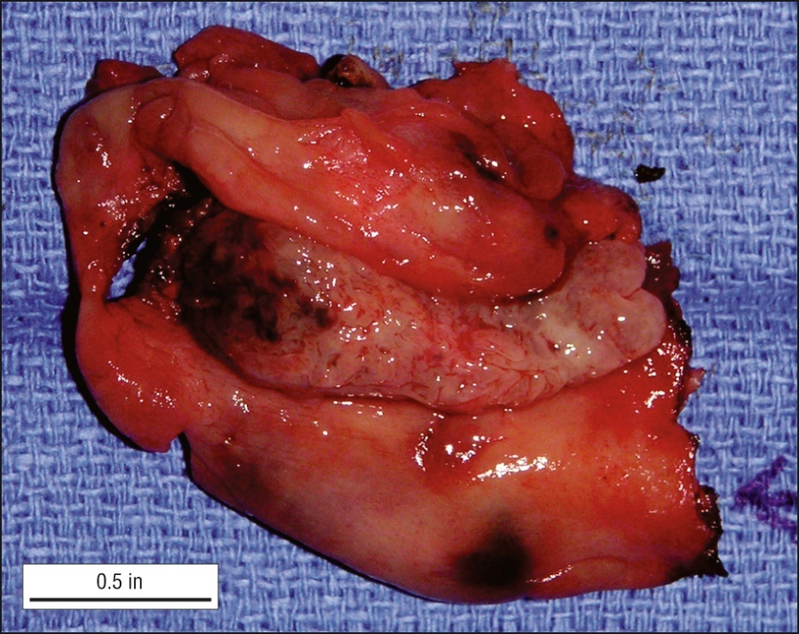
Figure (3): En bloc specimen excised through transnasal endoscopic medial maxillectomy (Tanna et al., 2007).

  - Evolution Toward Anatomy-Preserving Endoscopic Medial Maxillectomy Techniques
Growing recognition of the functional morbidity associated with classical endoscopic medial maxillectomy has led to a progressive shift toward anatomy-preserving surgical strategies. Sinonasal IP is a benign disease with long-term survival, making preservation of nasal physiology and postoperative quality of life increasingly important outcome measures alongside oncologic control (Pagella et al., 2017). This shift toward anatomy-preserving surgical strategies has been facilitated by advances in endoscopic visualization, angled optics, and a better understanding of tumor attachment patterns within the maxillary sinus (Zhou et al., 2018).
One of the earliest modifications aimed at reducing morbidity involved preserving the inferior turbinate during EMM. The inferior turbinate is essential for regulating nasal ventilation, humidification, and temperature control. Its preservation helps maintain normal nasal physiology and reduces postoperative crusting and symptoms associated with empty nose syndrome, while still allowing adequate surgical access in selected cases (Pagella et al., 2017).
Preservation of the nasolacrimal duct was another important step toward functional conservation. Transection of the duct during classical EMM is a well-recognized cause of postoperative epiphora and may necessitate secondary procedures such as dacryocystorhinostomy to restore adequate lacrimal drainage (Nakayama et al., 2020). Modified techniques that preserve or mobilize the nasolacrimal duct have demonstrated a substantial reduction in lacrimal complications without compromising exposure of the maxillary sinus or increasing recurrence rates (Suzuki et al., 2017).
Nakayama and colleagues described the EMMM as a technique that preserves both the nasolacrimal duct and inferior turbinate while providing wide entry to the maxillary sinus (Nakayama et al., 2012). Their initial reports demonstrated favorable oncologic outcomes with low recurrence rates and significantly reduced postoperative morbidity. Subsequent studies have supported EMMM as a reliable alternative to classical EMM in appropriately selected patients (Fig. 4) (Nakayama et al., 2020).

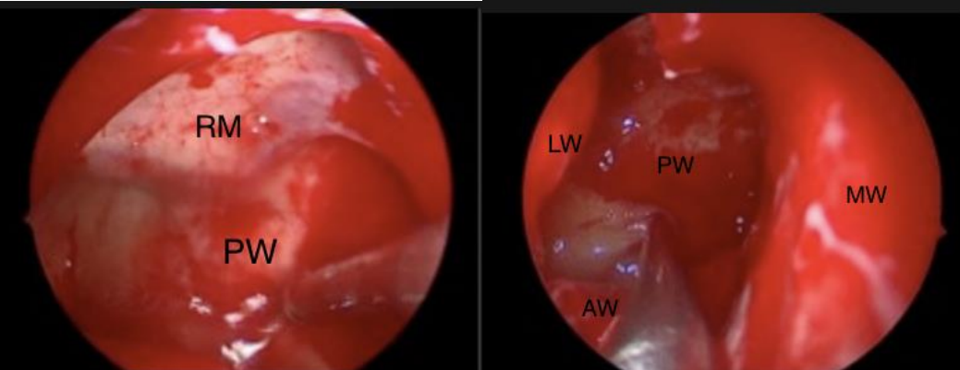

Figure (4): (a) Limited access to maxillary sinus following MMA (b) Following EMMM, all walls became visible (Grahitanindya et al., 2024).

To improve access to the anterior, lateral and inferior regions of the maxillary sinus, including the prelacrimal and alveolar recesses, the prelacrimal recess approach was developed. This technique enables direct entry into the maxillary sinus anterior to the nasolacrimal duct while preserving both the duct and inferior turbinate (Liang et al., 2024; Nakayama et al., 2020). Current evidence suggests that this approach offers excellent visualization of common tumor attachment sites and is associated with low recurrence rates and positive functional outcomes.
Extended anterior and inferior endoscopic approaches have also been developed to manage malignancies involving the anterior maxillary wall or alveolar recess. Although technically demanding, these approaches widen the surgical corridor while still using an endonasal route and preserving important anatomical structures (Huang et al., 2021; Zhou et al., 2018).
Overall, anatomy-preserving endoscopic medial maxillectomy techniques presents a shift in surgical philosophy towards personalized treatment planning. Instead of a standardized method, modern management focuses on choosing the least invasive technique that enables the complete removal of the tumor attachment site while preserving nasal anatomy and function (Zhou et al., 2018; Lund et al., 2010).

3.4. Oncologic Outcomes and Recurrence
Recurrence is closely related to incomplete removal of the tumor attachment site. Anatomy-preserving techniques, when performed meticulously, show recurrence rates comparable to classical EMM (5–15%) (Huang et al., 2021).
Prelacrimal and extended approaches allow thorough removal from traditionally high-risk regions, maintaining oncologic efficacy (Liang et al., 2024).
3.5. Functional Outcomes
Maintaining the integrity of the inferior turbinate and nasolacrimal duct improves nasal airflow, humidification, and lacrimal function, reducing crusting, empty nose syndrome, and epiphora (Bertazzoni et al., 2017). Patient-reported quality of life is also improved compared to classical EMM (Suzuki et al., 2017).

- Discussion
The surgical treatment of sinonasal IP has been advanced significantly in recent decades, moving from radical external procedures to refined endoscopic techniques. Traditional external approaches provided extensive exposure but came with significant morbidities and cosmetic concerns (Lund et al., 2010).
The introduction of endoscopic medial maxillectomy was a major breakthrough, providing better visualization of the maxillary sinus and tumor attachment sites while also reducing surgical morbidity (Robey & Sindwani R, 2011).
Despite its effectiveness in treating cancer, classical endoscopic medial maxillectomy is known to have functional limitations due to resection of the inferior turbinate and nasolacrimal duct (Nakayama et al., 2012). Recognition of these drawbacks has led to the development of anatomy-preserving modifications that aim to maintain nasal physiology and support patient well-being (Nakayama et al., 2020; Pagella et al., 2017).
Techniques such as EMMM, prelacrimal recess approaches, and extended anterior or inferior endoscopic approaches showcase this shift towards functional preservation.
Accumulating evidence indicates that anatomy-preserving techniques achieve oncologic outcomes comparable to those of classical EMM when meticulous attention is paid to complete removal of the tumor attachment site and underlying bone. Reported recurrence rates generally range between 5% and 15%, supporting the oncologic safety of these approaches in appropriately selected patients. Careful preoperative imaging remains essential for identifying tumor origin and guiding individualized surgical planning (Kim et al., 2012; Zhou et al., 2018).
Functional outcomes have emerged as a critical measure of surgical success in benign sinonasal disease.
Anatomy-preserving techniques consistently demonstrate improved nasal function, lower rates of epiphora, and enhanced patient-reported quality of life compared with more destructive approaches (Pagella et al., 2017; Suzuki et al., 2017). These benefits are particularly relevant in patients with long-life expectancy and reinforce the importance of balancing oncologic control with the preservation of sinonasal anatomy.
The evolution towards anatomy-preserving surgery reflects a broader trend in endoscopic sinonasal surgery: tailoring the extent of resection to tumor location and attachment while minimizing unnecessary tissue sacrifice. This approach requires advanced endoscopic expertise, detailed knowledge of sinonasal anatomy, and appropriate instrumentation. Individualized surgical planning remains central to optimizing both oncologic and functional outcomes (Lund et al., 2010; Zhou et al., 2018).

- Conclusion
Anatomy-preserving endoscopic medial maxillectomy (EMM) represents the current standard for maxillary sinus inverted papilloma (IP), providing effective tumor control with reduced morbidity. Preservation of the inferior turbinate and nasolacrimal duct, along with prelacrimal and extended approaches, allows for tailored surgery that maintains nasal function. Careful preoperative assessment, meticulous technique, and long-term follow-up are essential for optimal oncologic and functional outcomes.
Funding: This work received no external funding.
Author Contributions:
Kholoud M. Hassan: Conceptualization, literature search, data curation, writing—original draft preparation, visualization, and manuscript preparation.
Alaa M. Abdelsamie: Conceptualization, methodology, supervision, critical review and editing of the manuscript, and validation of the scientific content.
Hossam M. Abdelazeem: Supervision, project administration, critical review and editing of the manuscript, and final approval of the version to be published.
All authors contributed to the article, reviewed the manuscript, and approved the final version for publication
Conflicts of interest: No conflicts of interest.

- References
Bertazzoni, G., Castelnuovo, P., Battaglia, P., Nocini, P., & Nicolai, P. (2017). Endoscopic approaches for inverted papilloma: A 15-year experience. Acta Otorhinolaryngologica Italica, 37(2), 101–108.
Bishop, J. A. (2017). OSPs and ESPs and ISPs, oh my! An update on sinonasal (Schneiderian) papillomas. Head and Neck Pathology, 11(3), 269–277. https://doi.org/10.1007/s12105-017-0799-9
Cannady, S. B., Batra, P. S., Sautter, N. B., Roh, H. J., & Citardi, M. J. (2007). New staging system for sinonasal inverted papilloma in the endoscopic era. The Laryngoscope, 117(7), 1283–1287. https://doi.org/10.1097/MLG.0b013e31803330f1
Chawla, A., Shenoy, J., Chokkappan, K., & Chung, R. (2016). Imaging features of sinonasal inverted papilloma: A pictorial review. Current Problems in Diagnostic Radiology, 45(5), 347–353.
Chhabra, N., & Houser, S. M. (2009). Endoscopic management of inverted papilloma: A review. Current Opinion in Otolaryngology & Head and Neck Surgery, 17(1), 24–29. https://doi.org/10.1097/MOO.0b013e32831cef44
Fulla, M., et al. (2020). Low prevalence of human papillomavirus DNA in sinonasal inverted papilloma and lack of association with recurrence. Acta Otolaryngologica, 140(3), 251–256. https://doi.org/10.1080/00016489.2019.1698560
Grahitanindya, D., Kusuma, I. B. G. H., Putra, I. B. S., & Permatasari, N. D. (2024). Endoscopic surgical approach of sinonasal inverted papilloma: A case report and mini review. GSC Advanced Research and Reviews, 18(02), 198–203.
Han, J. K., Smith, T. L., Loehrl, T., Toohill, R. J., & Smith, M. M. (2001). An evolution in the management of sinonasal inverted papilloma. The Laryngoscope, 111, 1395–1400. https://doi.org/10.1097/00005537-200108000-00010
Holzmann, D., Stammberger, H., & Reitsamer, H. A. (2006). Management of inverted papillomas: A 10-year experience. American Journal of Rhinology, 20(5), 483–489. https://doi.org/10.2500/ajr.2006.20.2875
Hosemann, W., Sauter, S., & Draf, W. (2003). Endoscopic sinus surgery for inverted papilloma: Indications, techniques, and outcomes. The Laryngoscope, 113(9), 1615–1620. https://doi.org/10.1097/00005537-200309000-00019
Huang, Z., Li, W., Cui, S., & Liu, Y. (2021). Extended anterior inferior approach for maxillary sinus inverted papilloma. International Forum of Allergy & Rhinology, 11(3), 450–459. https://doi.org/10.1177/19458924211025371
Kamel, R. (1995). Endoscopic medial maxillectomy. Otolaryngology–Head and Neck Surgery, 112(2), 179–184.
Kim, C. H., Chung, S. K., et al. (2012). Imaging features of sinonasal inverted papilloma. AJNR American Journal of Neuroradiology, 33(7), 1348–1354. https://doi.org/10.3174/ajnr.A3038
Krouse, J. H. (2000). Endoscopic management of inverted papilloma. The Laryngoscope, 110(6), 899–904. https://doi.org/10.1097/00005537-200006000-00015
Liang, N., et al. (2024). Prelacrimal recess approach for maxillary sinus inverted papilloma: A 15-year experience from a single center. European Archives of Oto-Rhino-Laryngology, 281(9), 4763–4771.
Lisan, Q., Laccourreye, O., & Bonfils, P. (2016). Sinonasal inverted papilloma: From diagnosis to treatment. European Annals of Otorhinolaryngology, Head and Neck Diseases, 133(5), 337–341. https://doi.org/10.1016/j.anorl.2016.08.004
Lund, V. J., Stammberger, H., Nicolai, P., Castelnuovo, P., Beal, T., Beham, A., et al. (2010). European position paper on endoscopic management of sinonasal inverted papilloma. Rhinology, 48(1), 1–25.
Meng, Y., Fang, G., Wang, X., et al. (2019). Origin site-based staging system of sinonasal inverted papilloma for application to endoscopic sinus surgery. Head and Neck, 41(2), 440–447. https://doi.org/10.1002/hed.25513
Nakayama, M., Imanishi, N., & Toida, M. (2020). Prelacrimal recess approach for maxillary sinus inverted papilloma: Long term outcomes. Rhinology, 58(3), 200–208. https://doi.org/10.4193/Rhino20.090
Nakayama, M., Imanishi, N., Shimada, M., Ayuse, T., & Inoue, T. (2012). Endoscopic modified medial maxillectomy for sinonasal inverted papilloma. American Journal of Rhinology & Allergy, 26(1), e27–e32. https://doi.org/10.2500/ajra.2012.26.3791
Nakayama, T., Tsunemi, Y., Kashiwagi, T., Kuboki, A., Yamakawa, S., Konno, W., et al. (2021). Comparison of current staging systems for sinonasal inverted papilloma. American Journal of Rhinology & Allergy, 35(1), 64–71. https://doi.org/10.1177/1945892420965615
Oikawa, K., Furuta, Y., Nakamaru, Y., Oridate, N., & Fukuda, S. (2007). Preoperative staging and surgical approaches for sinonasal inverted papilloma. Annals of Otology, Rhinology & Laryngology, 116, 674–680. https://doi.org/10.1177/000348940711600910
Ojiri, H., et al. (2000). MRI characteristics of inverted papilloma. American Journal of Roentgenology, 175, 465–468. https://doi.org/10.2214/ajr.175.2.1750465
Pagella, F., Matti, E., Pusateri, A., & Tomacelli, G. L. (2017). Patient reported quality of life following anatomy preserving techniques. Acta Otorhinolaryngologica Italica, 37(4), 305–312.
Robey, A. S., & Sindwani, R. (2011). Endoscopic vs open resection of inverted papilloma: A systematic review and meta analysis. International Forum of Allergy & Rhinology, 1(4), 250–257. https://doi.org/10.1002/alr.20157
Sauter, A., & Draf, W., et al. (2007). Endoscopic medial maxillectomy for inverted papilloma. The Laryngoscope, 117(2), 211–218. https://doi.org/10.1097/MLG.0b013e31802fcd27
Suzuki, M., Katori, Y., Nakamura, Y., Yokota, M., & Murakami, S. (2017). Long term outcomes of anatomy preserving medial maxillectomy. Otolaryngology–Head and Neck Surgery, 157(5), 833–839. https://doi.org/10.1177/0194599817712257
Tanna, N., Edwards, J. D., Aghdam, H., & Sadeghi, N. (2007). Transnasal endoscopic medial maxillectomy as the initial oncologic approach to sinonasal neoplasms: The anatomic basis. Archives of Otolaryngology–Head & Neck Surgery, 133(11), 1139–1142. https://doi.org/10.1001/archotol.133.11.1139
Wormald, P. J., Ooi, E., van Hasselt, C. A., & Nair, S. (2003). Endoscopic removal of sinonasal inverted papilloma including endoscopic medial maxillectomy. The Laryngoscope, 113(5), 867–873. https://doi.org/10.1097/00005537-200305000-00017
Zhou, B., Liu, Y., Han, D. M., Cui, S. J., Huang, Q., & Wang, C. S. (2018). Endoscopic management of inverted papilloma: A contemporary review. Frontiers in Oncology, 8, 622. https://doi.org/10.3389/fonc.2018.00622

